**SauceDemo Automation Test Documentation**

## 1. Overview

**Application:** SauceDemo – <https://www.saucedemo.com/>

**Automation Framework:** Robot Framework  
**Test Type:** Functional UI automation  
**Browser(s):** Chrome  
**Date:** 2025-11-04

**Objectives**

* Automate functional regression testing for SauceDemo web application

## 2. Automation Project Structure

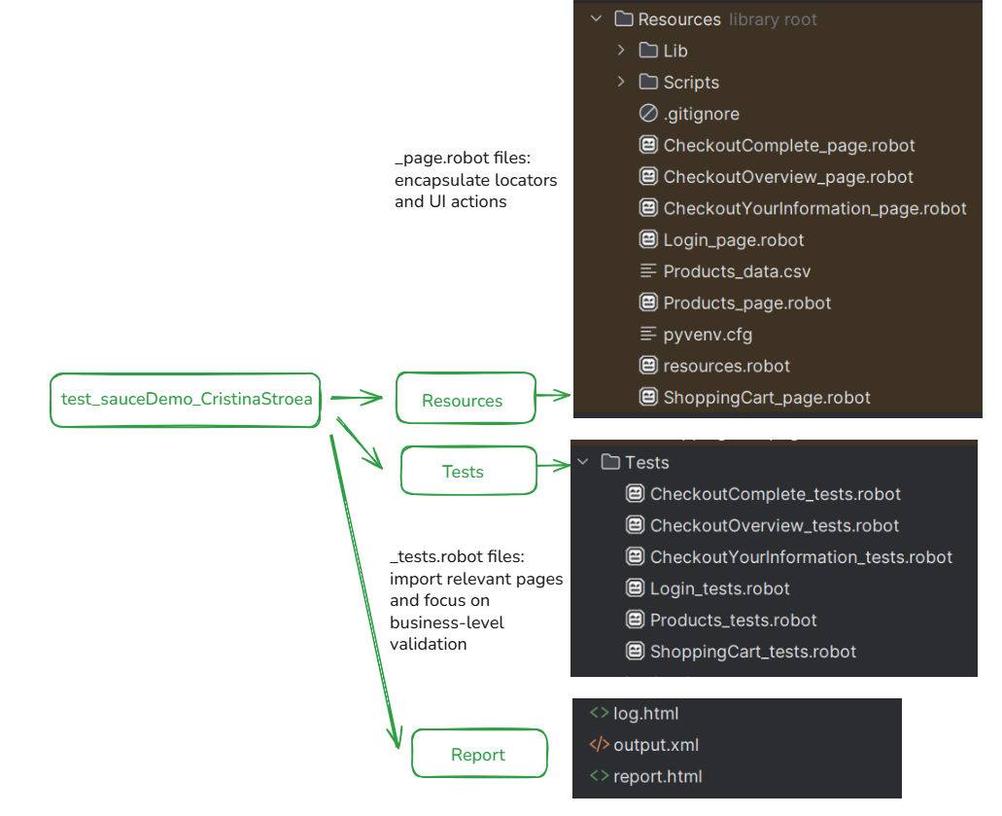

### Login Page

**Page Name:** Login Page

**URL:** https://www.saucedemo.com/  
**Files Path:** Resources/Login_page.robot, Tests/Login_tests.robot  
**Purpose:** Handles user authentication - allows users to log into the SauceDemo application using valid credentials.

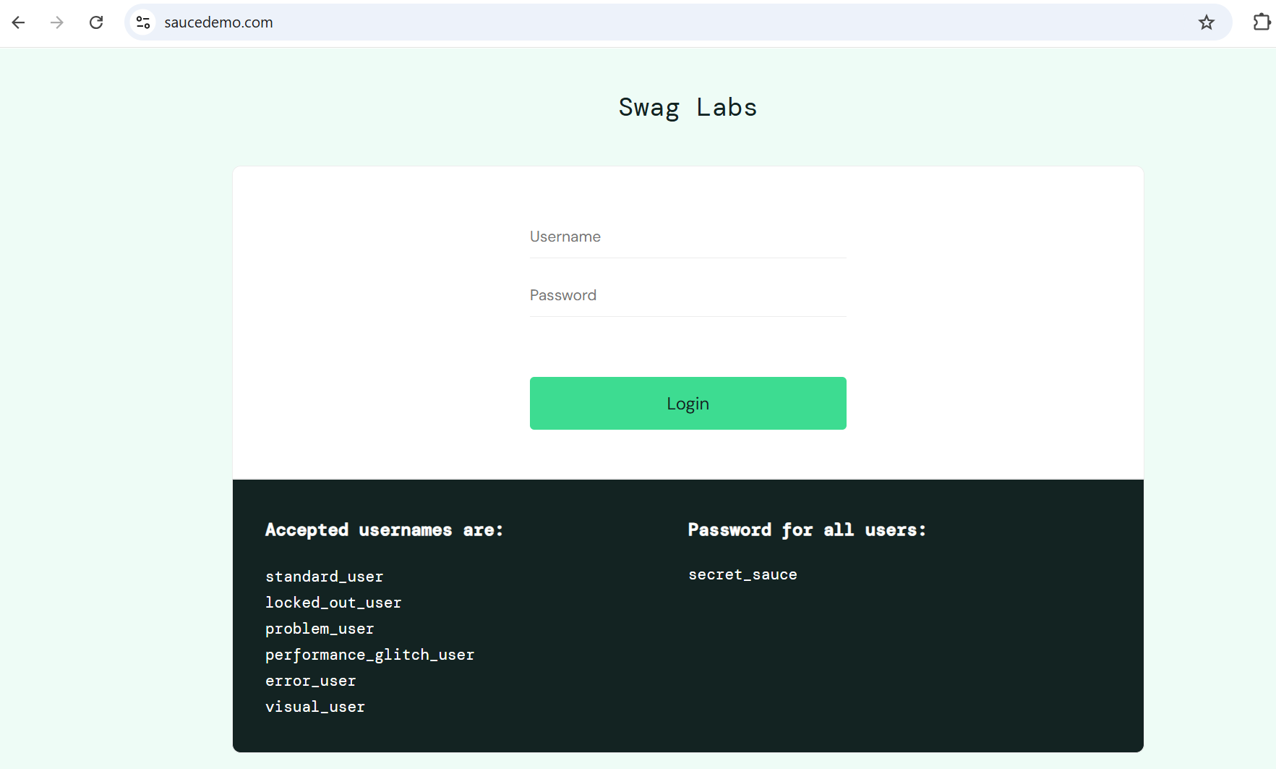

The login tests are designed to support all available users in the SauceDemo application.  
Each test can be executed based on assigned tags

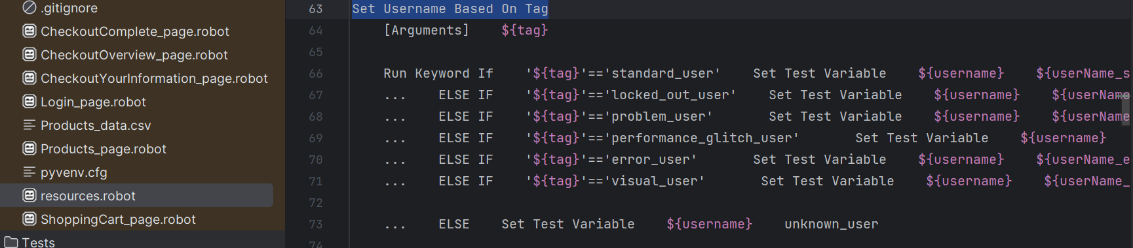

Tests can be executed using specific tag (example: robot -v ACTIVE_USER:problem_user .) or without tag (robot . ), where standard_user user will be used.

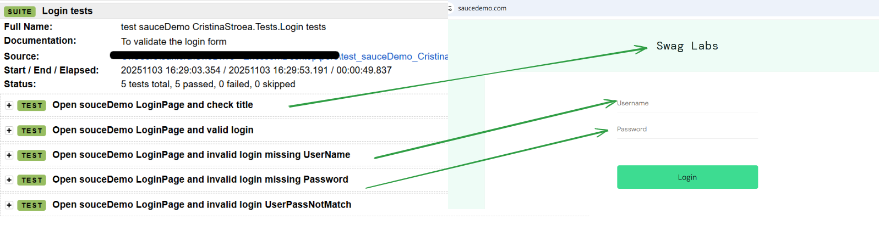

### Products Page

**Page Name:** Products Page

**URL:** https://www.saucedemo.com/inventory.html  
**Files Path:** Resources/Products_page.robot, Tests/Products_tests.robot  
**Purpose:** The Products page (Inventory page) displays the catalog of available items after a successful login. It allows users to view product details (name, description, price), to add or remove items from the shopping cart, and sort products (by name or by price).

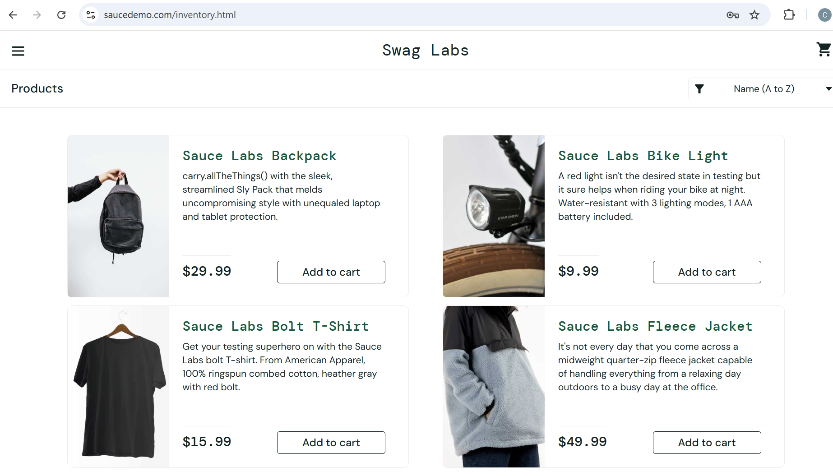

#### Defects:

##### visual_user: Shopping cart not displayed properly

Steps to reproduce:

1. Log in using Username: visual_user and Password: secret_sauce > user is redirected to Products page Shopping Cart page
2. Verify if Shopping Cart icon is displayed properly

Expected results: The shopping cart section should be shifted toward the right margin of the page.

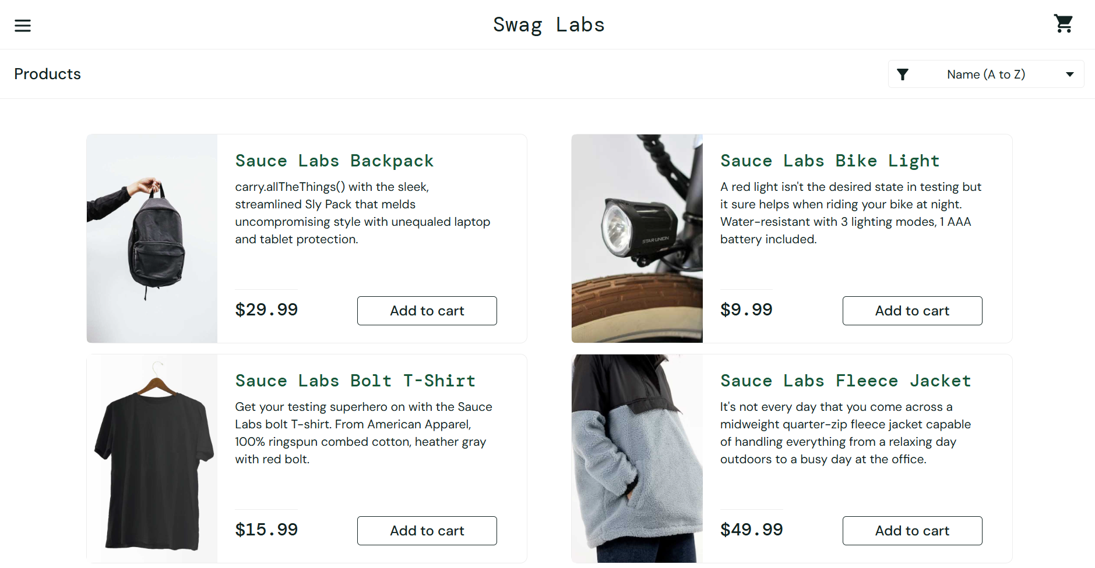

Actual results: The shopping cart section is misaligned, not appearing shifted toward the right margin of the page – aligned with left margin of sort dropdown

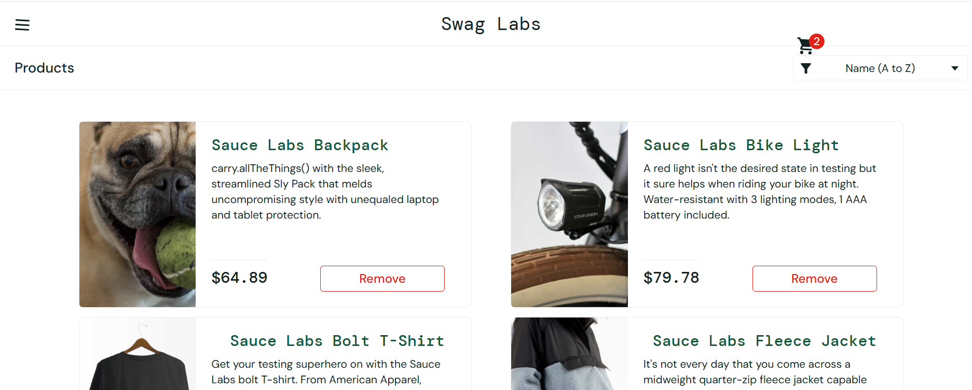

Test Failed:

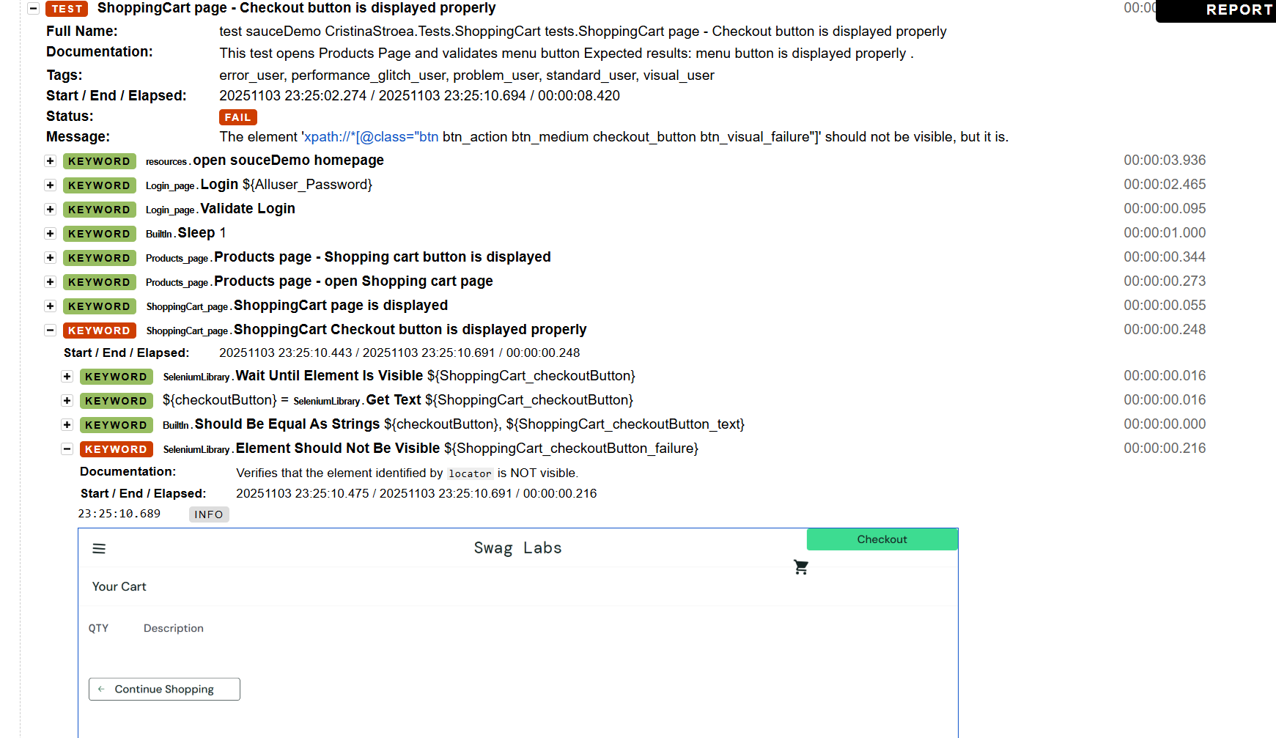

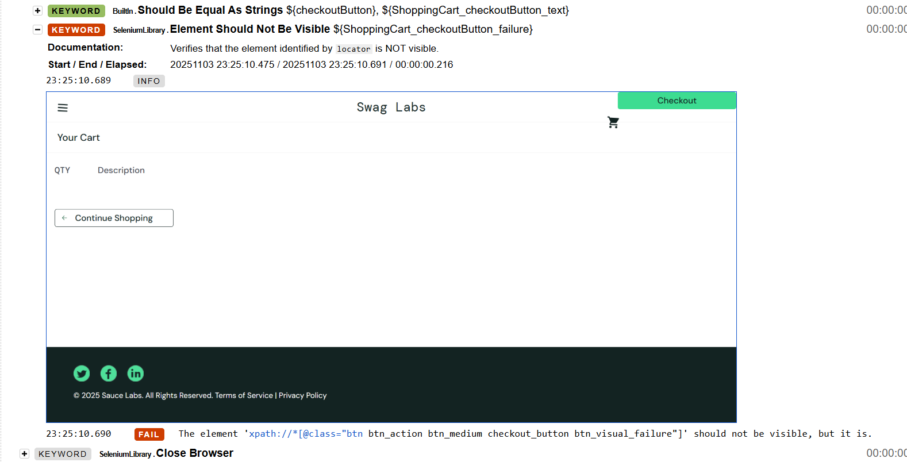

##### visual_user: menu icon appears slightly tilted

Steps to reproduce:

1. Log in using Username: visual_user and Password: secret_sauce > user is redirected to Products page Shopping Cart page
2. Verify if menu icon is displayed properly

Expected results: menu icon is properly aligned and not tilted

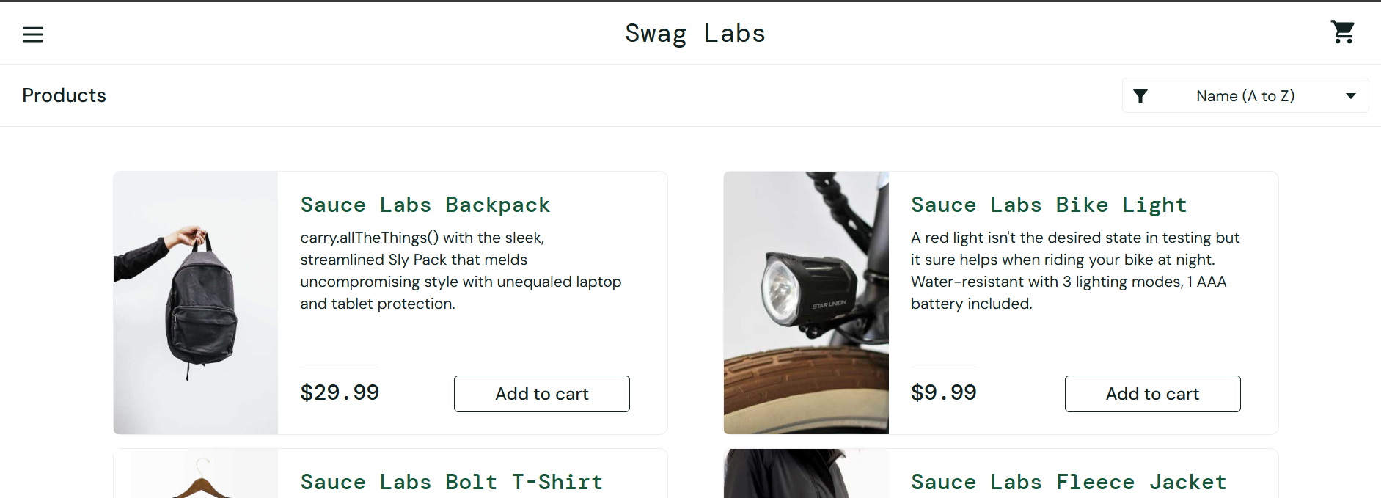Actual results: menu icon appears slightly tilted

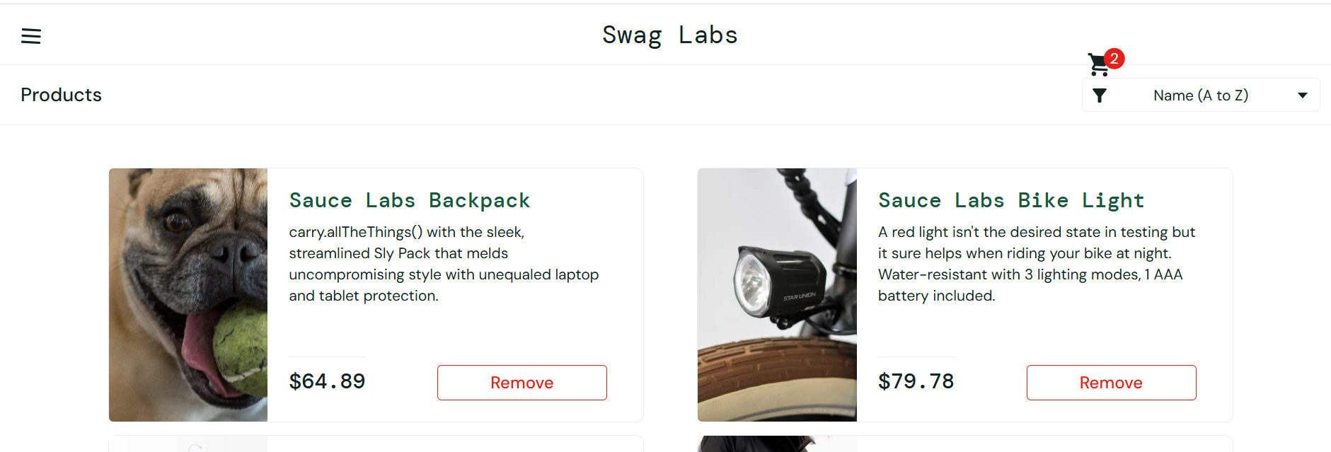

##### visual_user: menu- close button appears slightly tilted

Steps to reproduce:

1. Log in using Username: visual_user and Password: secret_sauce > user is redirected to Products page Shopping Cart page
2. Click on menu icon > menu is opened
3. Check if Close button is properly alligned

Expected results: menu- close button is properly aligned

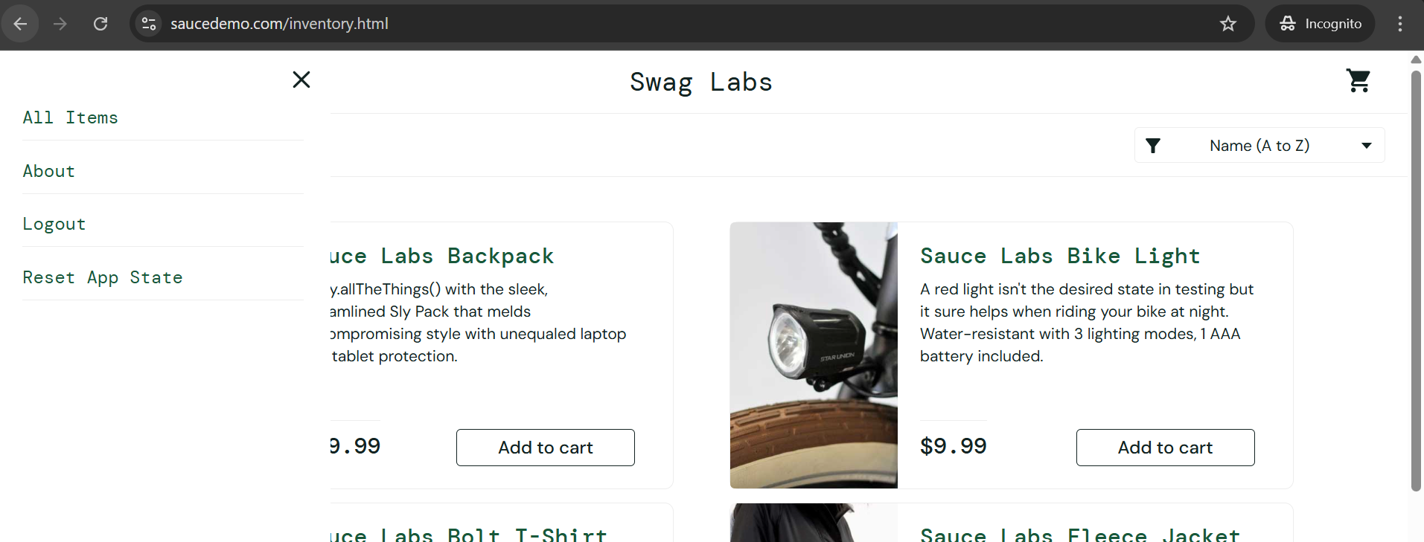

Actual results: menu- close button appears slightly tilted

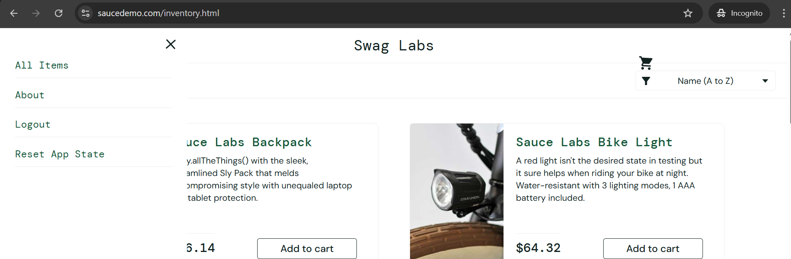

Test Failed:

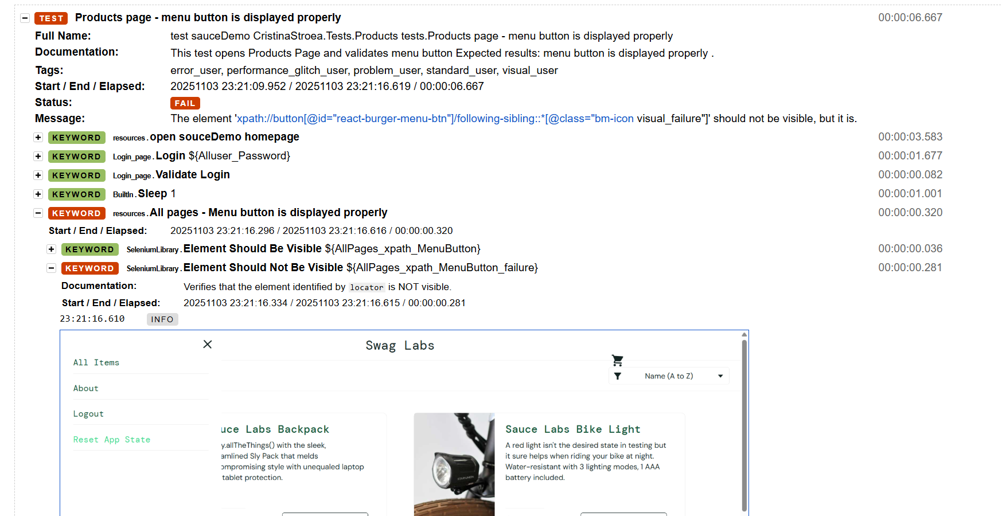

##### visual_user: product prices are inconsistent and change after refreshing the page

Steps to reproduce:

1. Log in using Username: visual_user and Password: secret_sauce > user is redirected to Products page Shopping Cart page
2. Note product prices
3. Refresh page and check value of prices again

Expected results: Product prices are consistent (not changed)

Actual results: prices are updated after page refresh

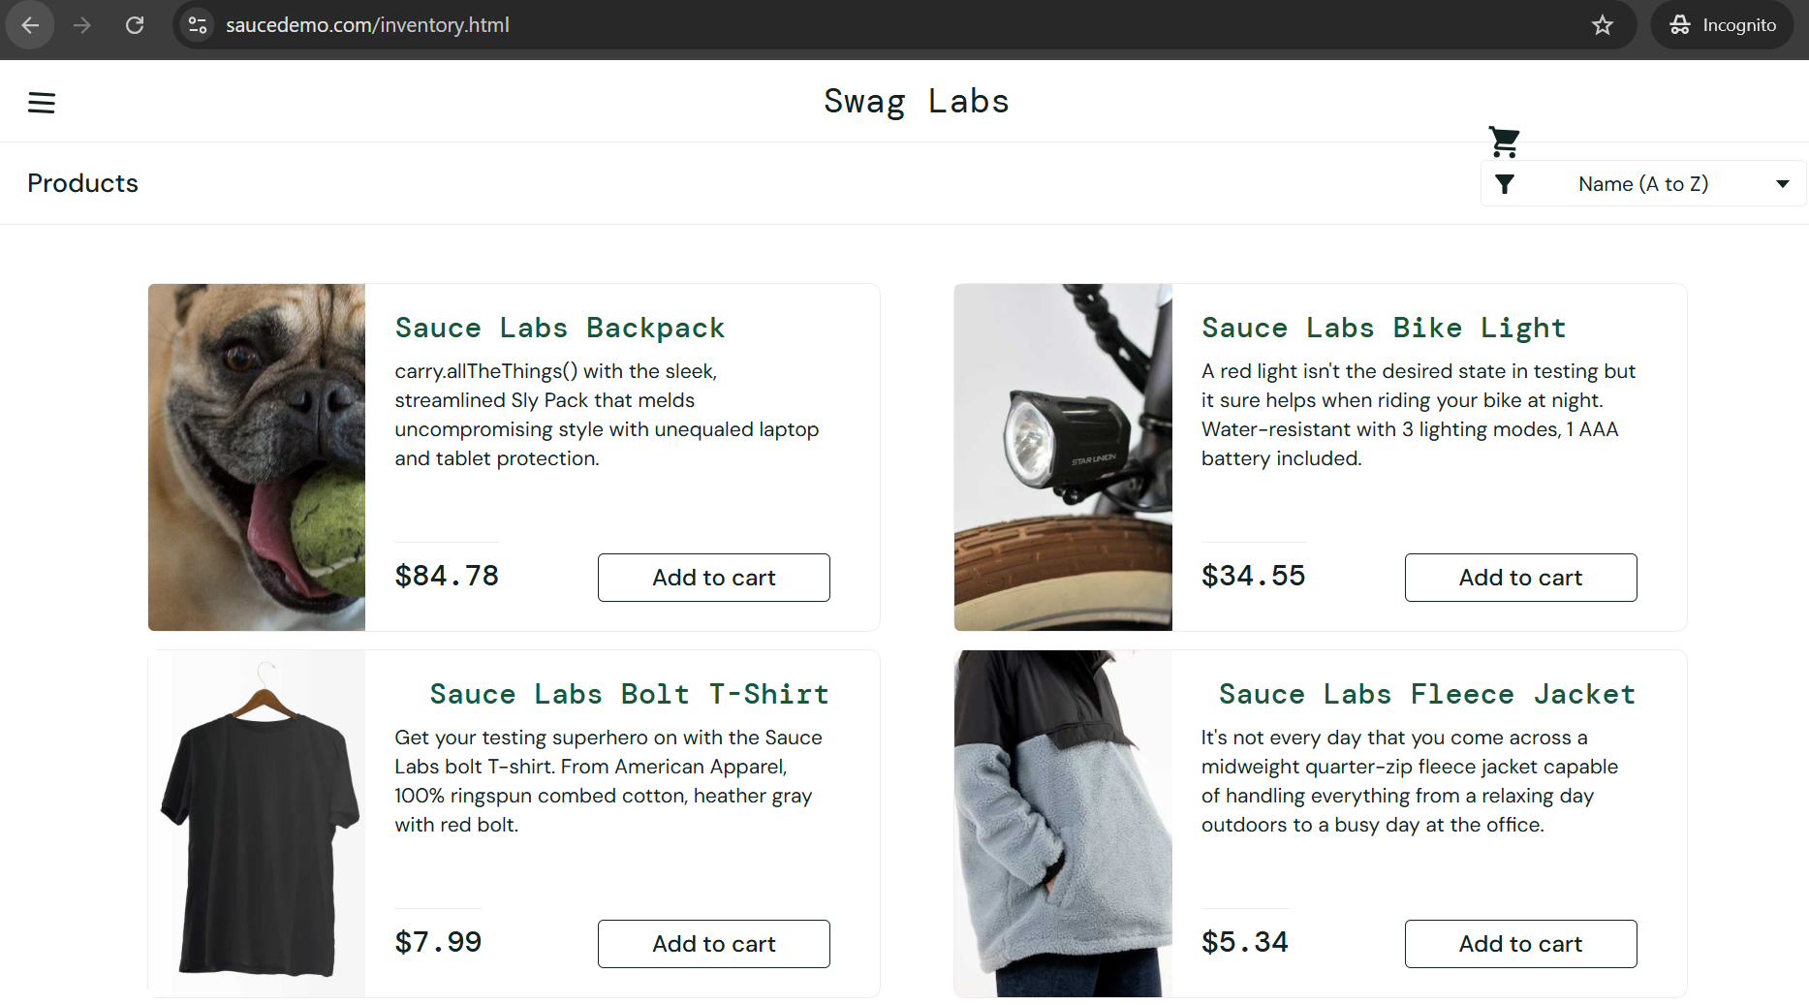

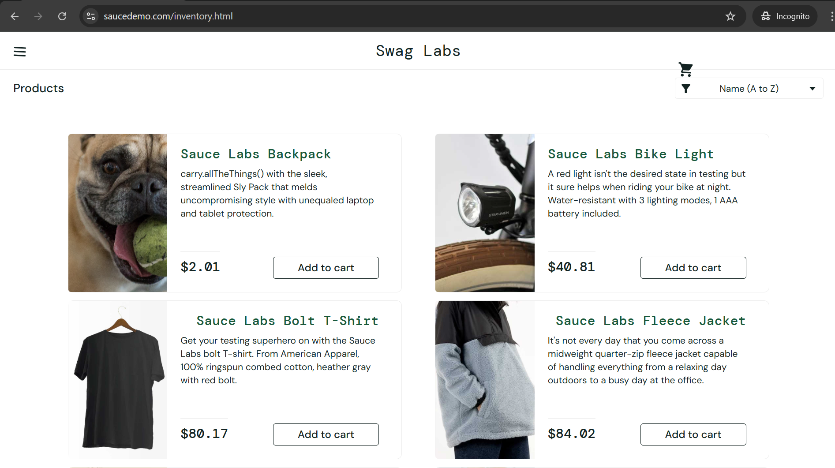

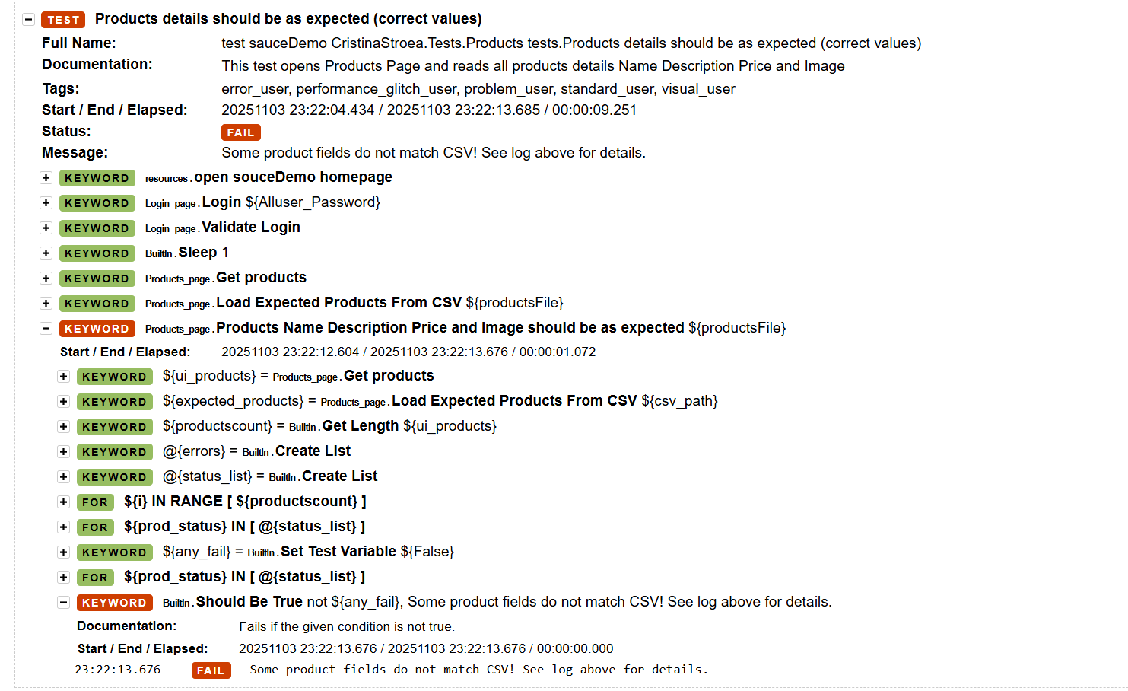

##### visual_user: sort is not working properly (impact from previous defect)

Steps to reproduce:

1. Log in using Username: visual_user and Password: secret_sauce > user is redirected to Products page
2. Open Sort dropdown and select an option (example: Price low to high)
3. Verify if sort is applied

Expected results: products are displayed based on the applied sort option

Actual results: sort is not working properly – order is not correct

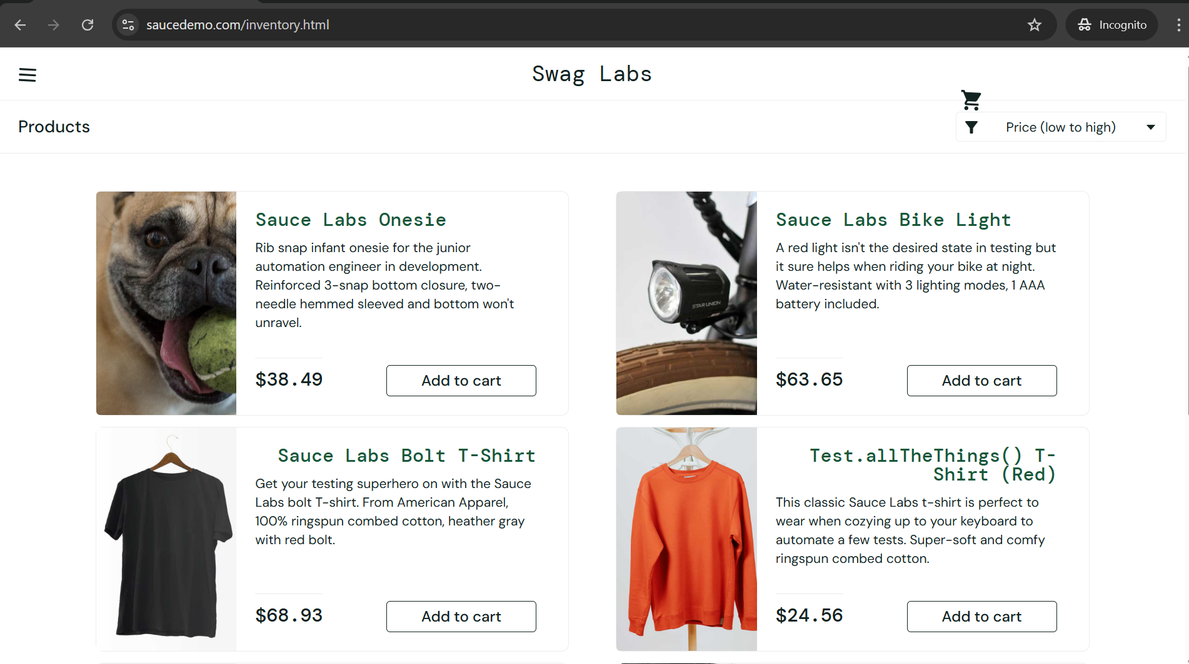

Test failed:

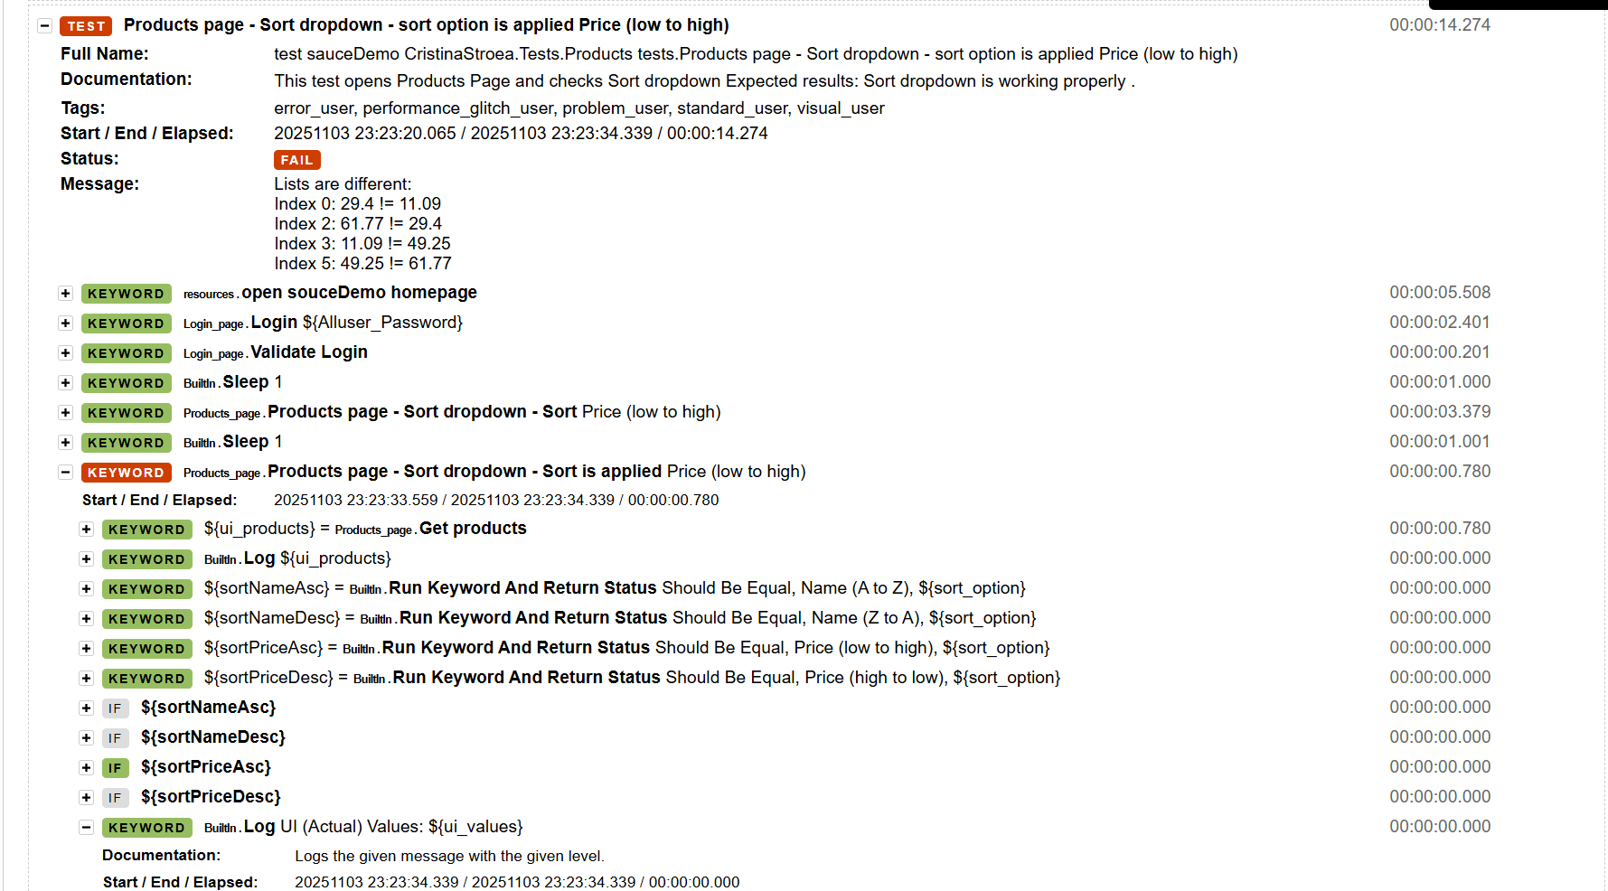

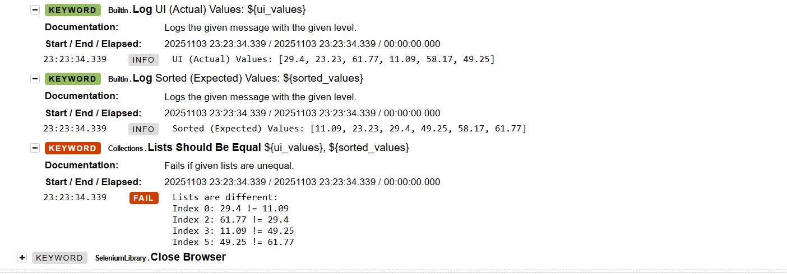

##### problem_user: sort is not selectable/ applied

Steps to reproduce:

1. Log in using Username: prblem_user and Password: secret_sauce > user is redirected to Products page
2. Open Sort dropdown and select an option (example: Price low to high)
3. Verify if sort is applied

Expected results: sort option is applied

Actual results: sort option is not selected or applied

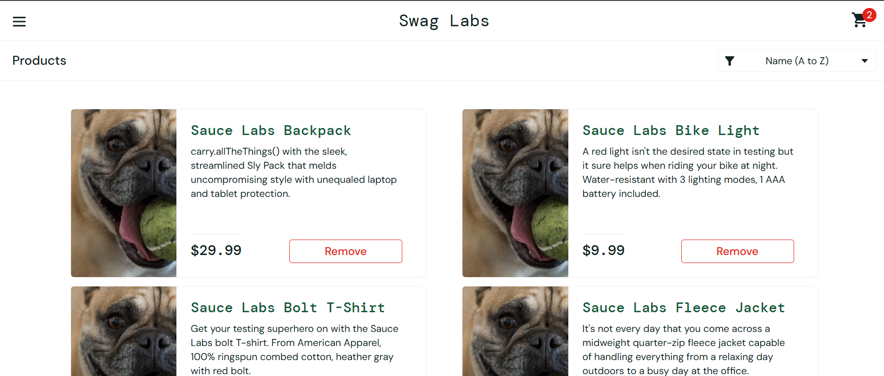

##### visual_user: Product names aligned to the right

Steps to reproduce:

1. Log in using Username: visual_user and Password: secret_sauce > user is redirected to Products page Shopping Cart page
2. Check alignment of product names

Expected results: All product names are aligned – the same for all products

Actual results: (example: Sauce Labs Bolt T-Shirt)

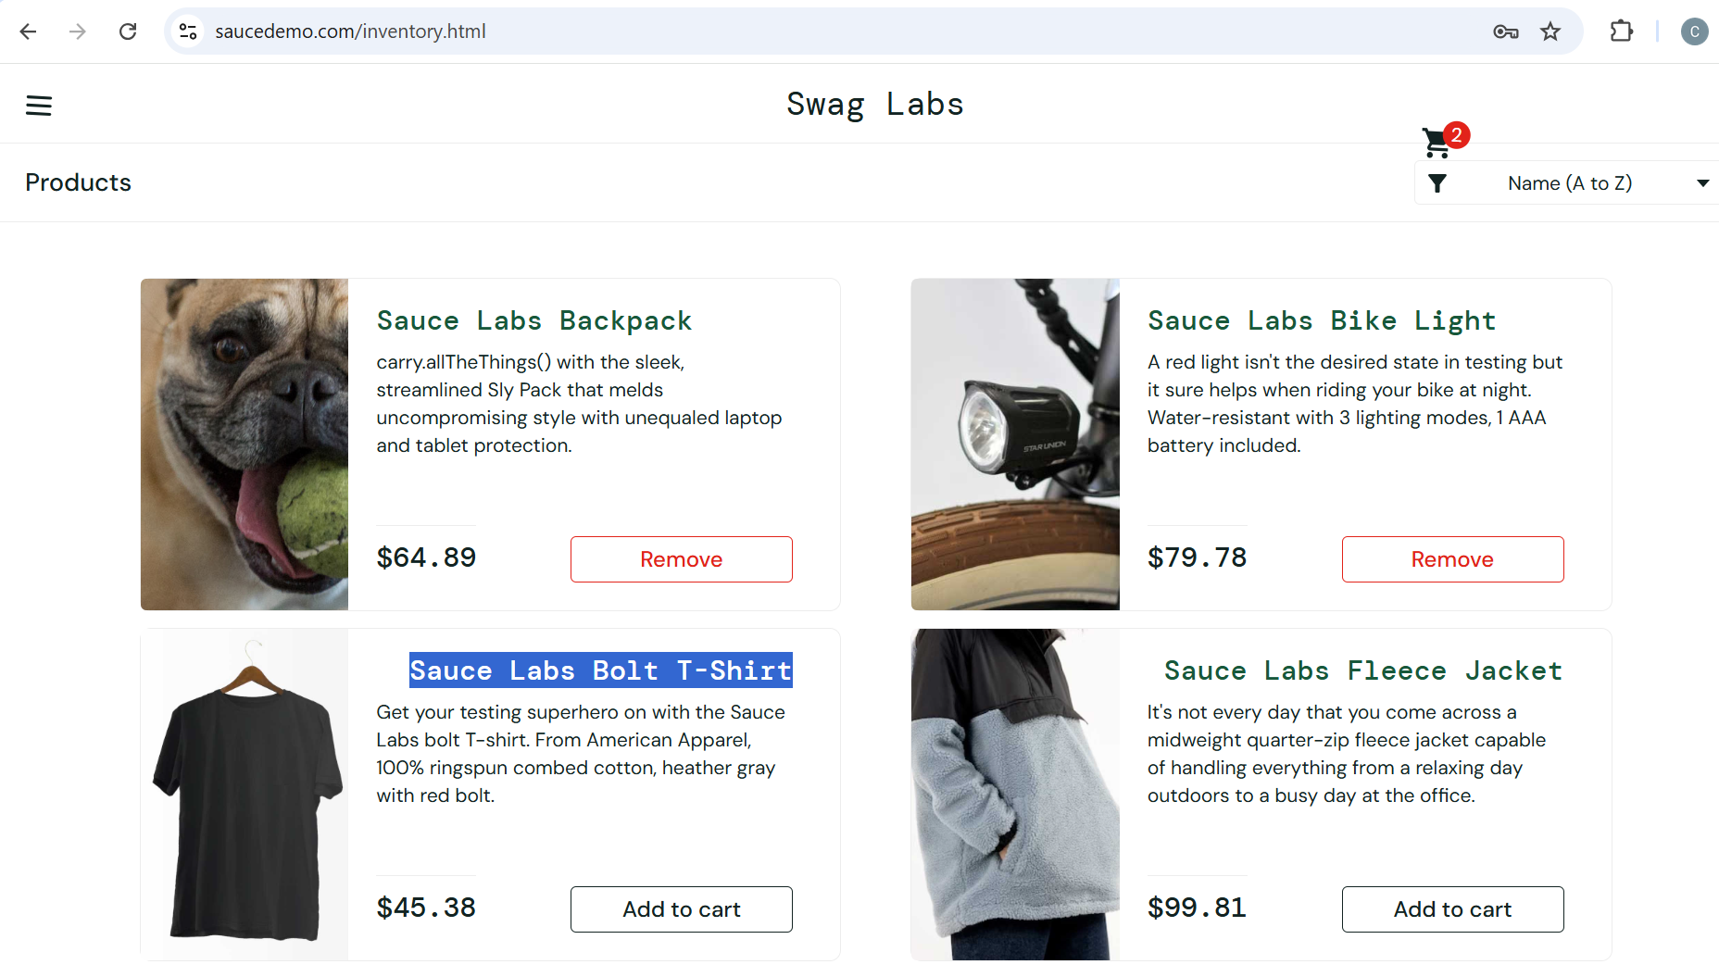

##### visual_user: Add to cart button is not aligned for all products (last product)

Steps to reproduce:

1. Log in using Username: visual_user and Password: secret_sauce > user is redirected to Products page Shopping Cart page
2. Check alignment of Add to cart/ Remove buttons

Expected results: all add/remove buttons are properly aligned

Actual result: last add/remove button is partially out of view on the page

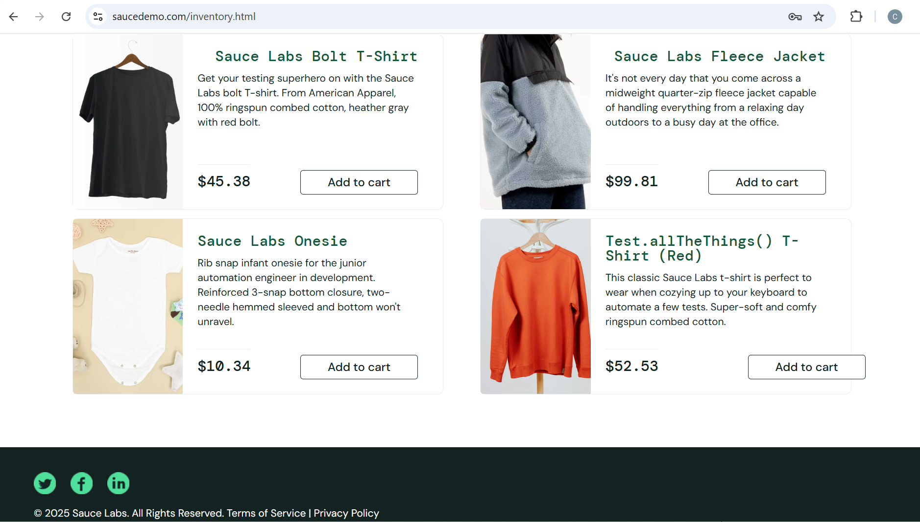

##### problem_user, error_user: Remove button is not clickable

Steps to reproduce:

1. Log in using Username: problem_user and Password: secret_sauce > user is redirected to Products page Shopping Cart page
2. Click on Add to cart button > button is replaced by Remove button
3. Click on Remove button

Expected results: Add to cart button becomes Remove button and vice versa

Actual results: Remove button is not clickable, product can not be removed on Products page. Product can be removed only from cart page

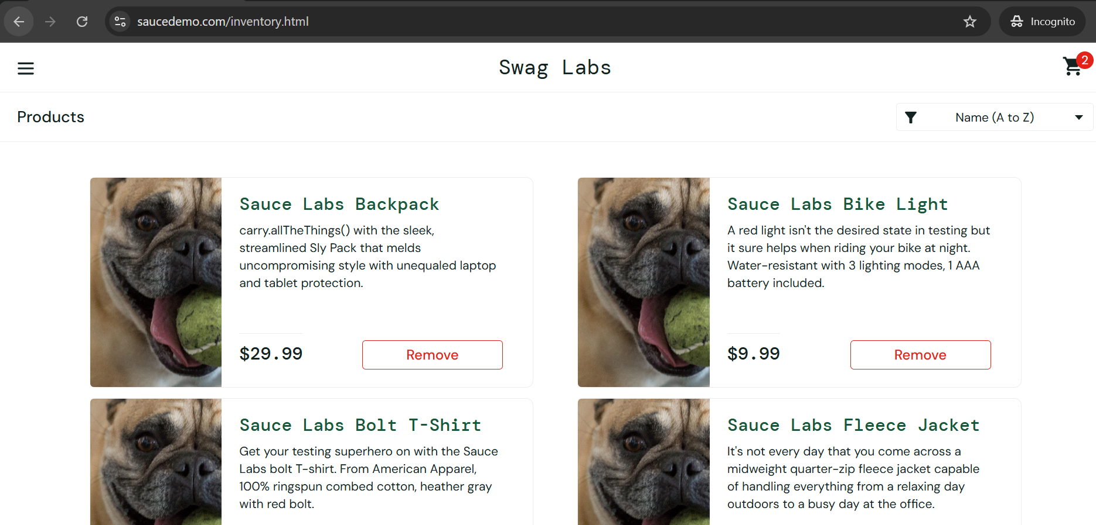

### Your Cart Page

**Page Name:** Your Cart Page

**URL:** https://www.saucedemo.com/cart.html  
**Files Path:** Resources/ ShoppingCart_page.robot, Tests/ ShoppingCart_tests.robot  
**Purpose:** The Shopping Cart page allows users to view all selected products before proceeding to checkout, to navigate back to the Products page or forward to the Checkout process.

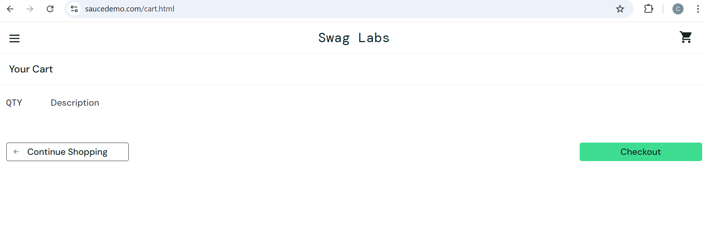

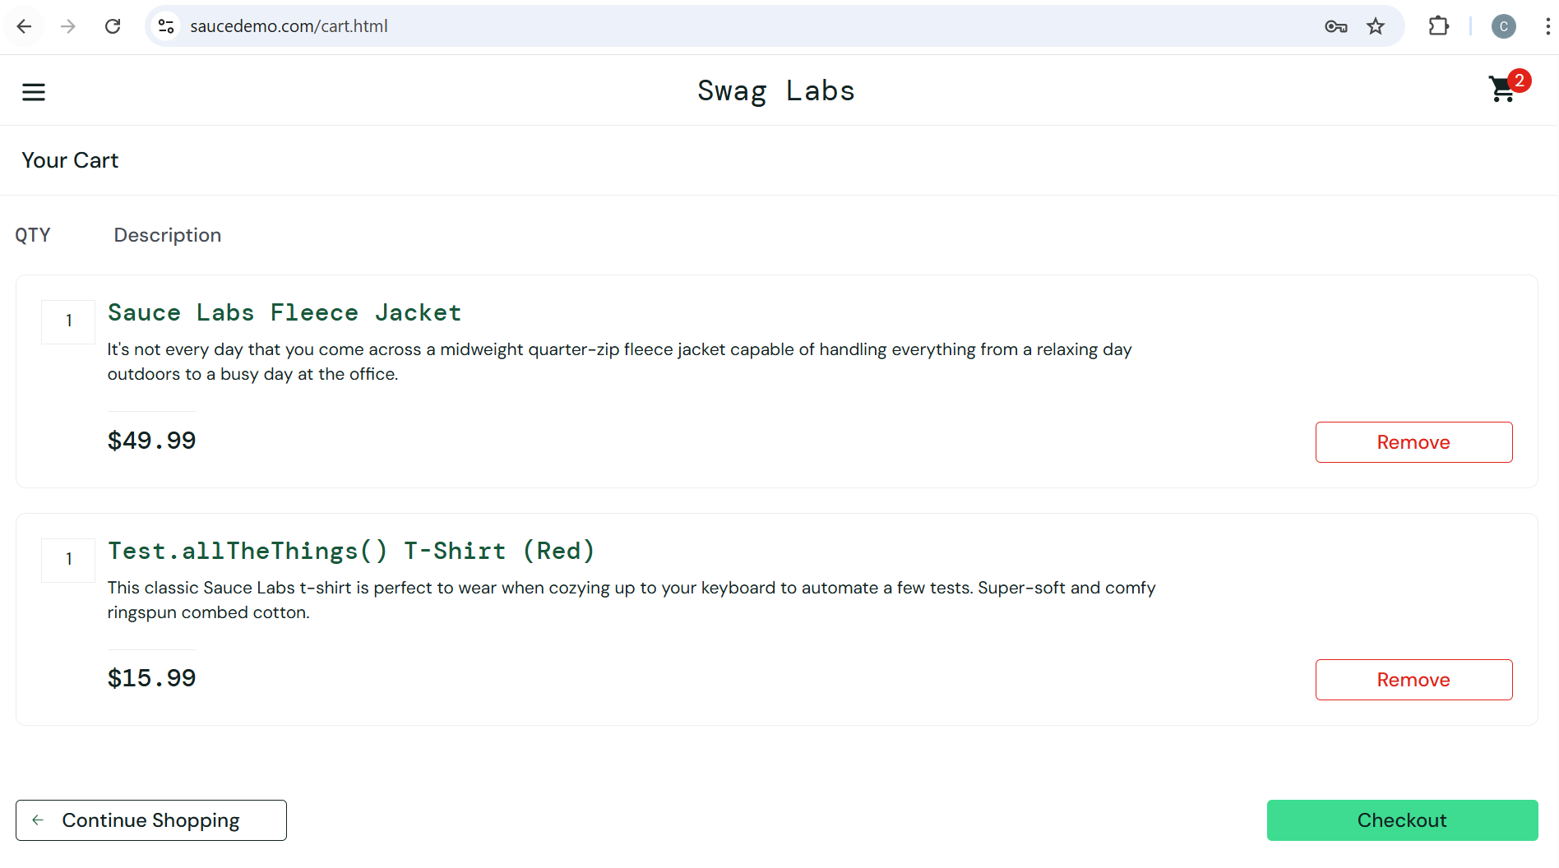

#### Defects:

##### visual_user: checkout button is misaligned (right top of the page)

Steps to reproduce:

1. Log in using Username: visual_user and Password: secret_sauce > user is redirected to Products page Shopping Cart page
2. Add products to cart (optional step)
3. Click on Shopping cart button > user is redirected to Your cart page
4. Check alignment of Checkout button

Expected results: checkout button is at the bottom of the page, aligned to the right

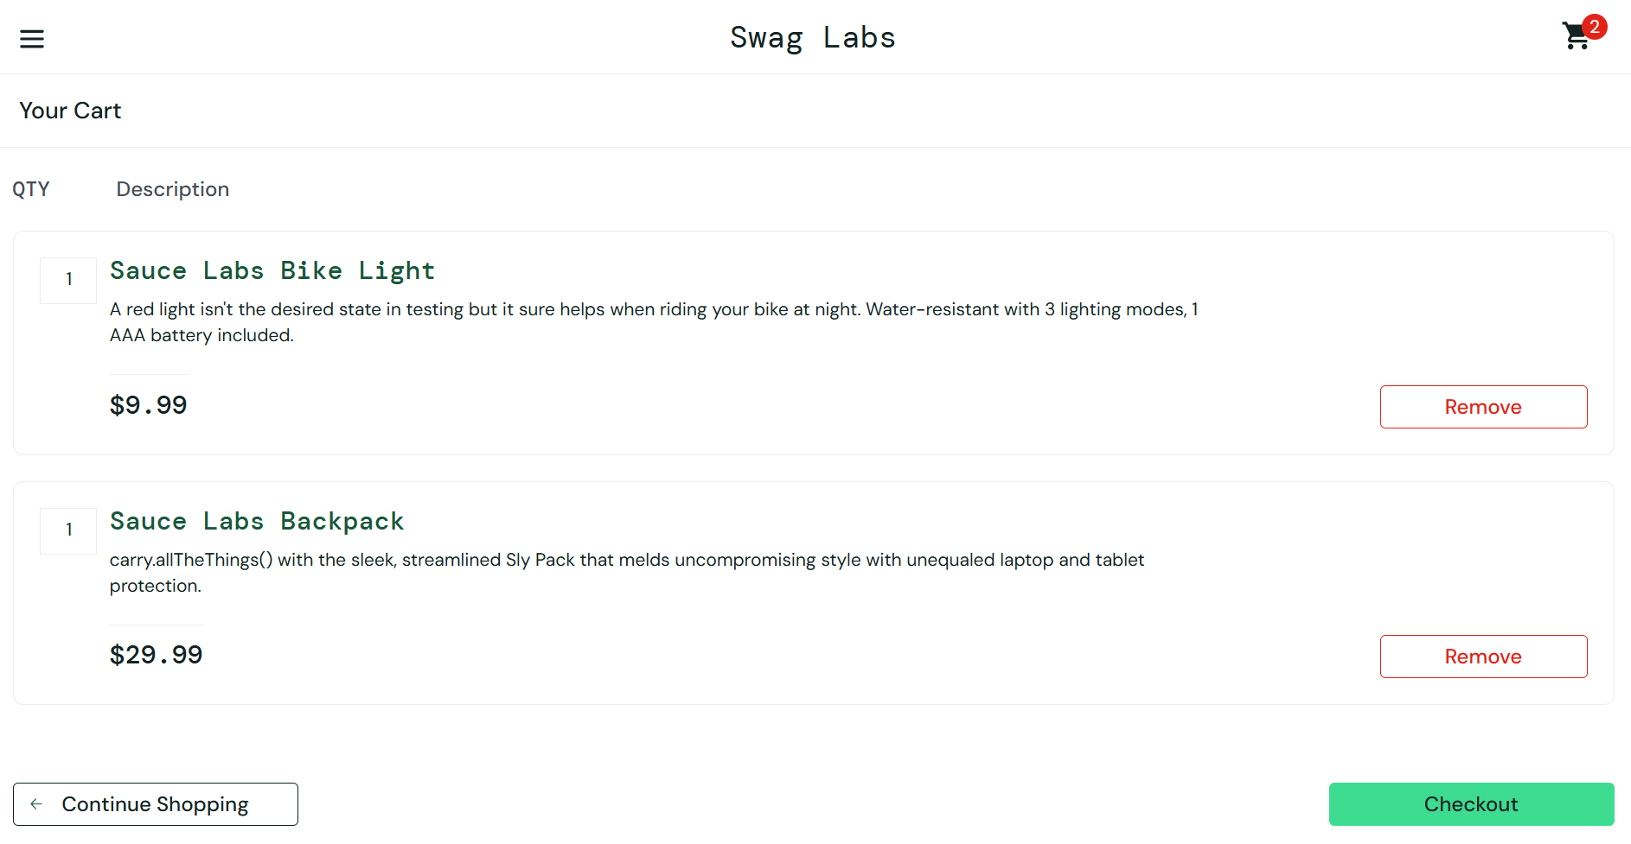

Actual results: checkout button is misaligned (right top of the page)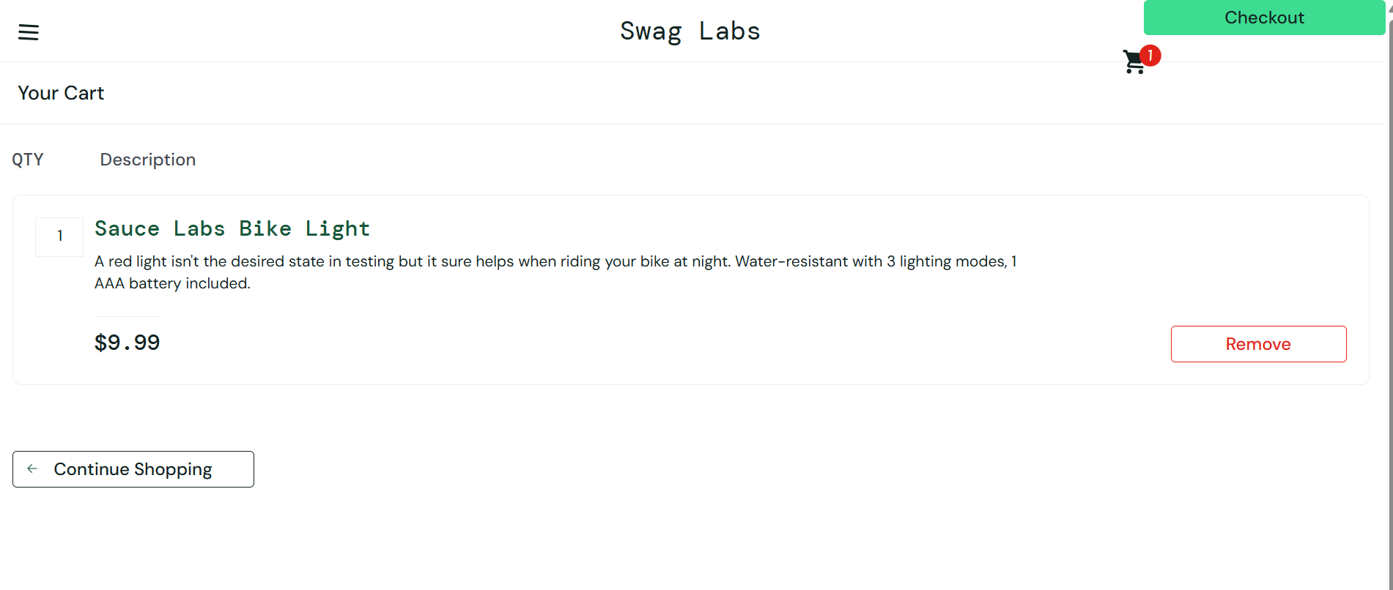

Test failed:

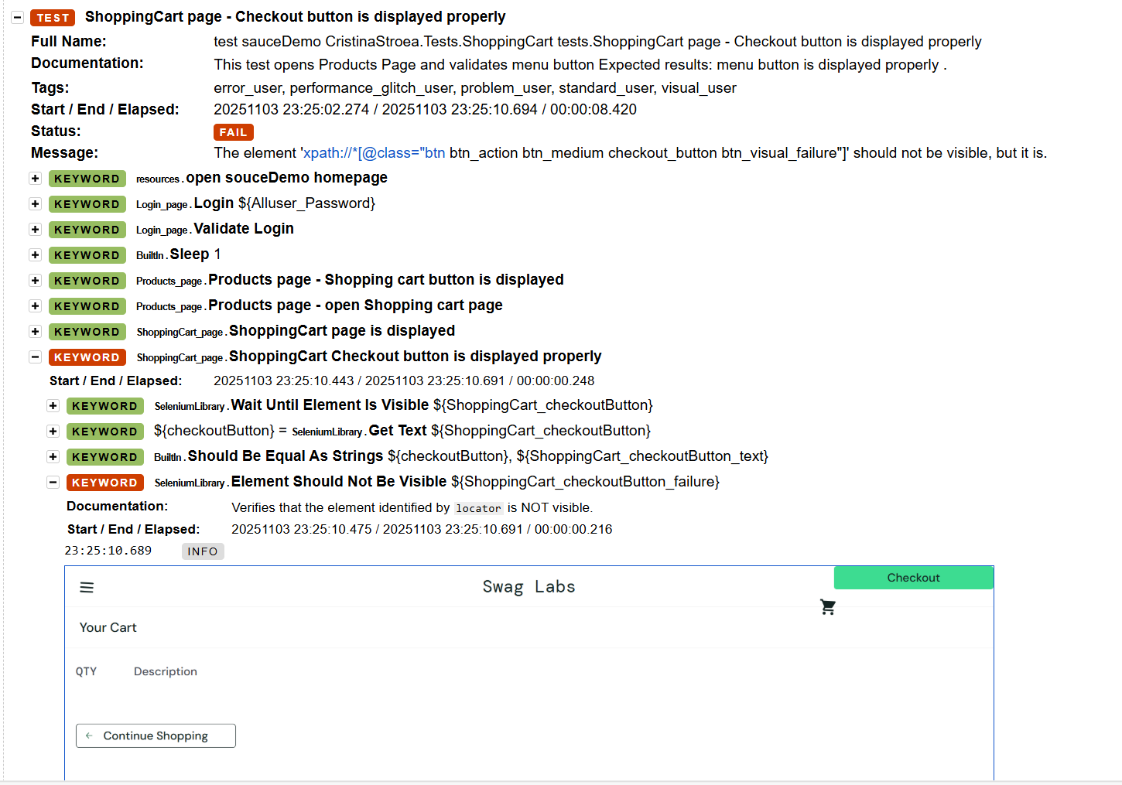

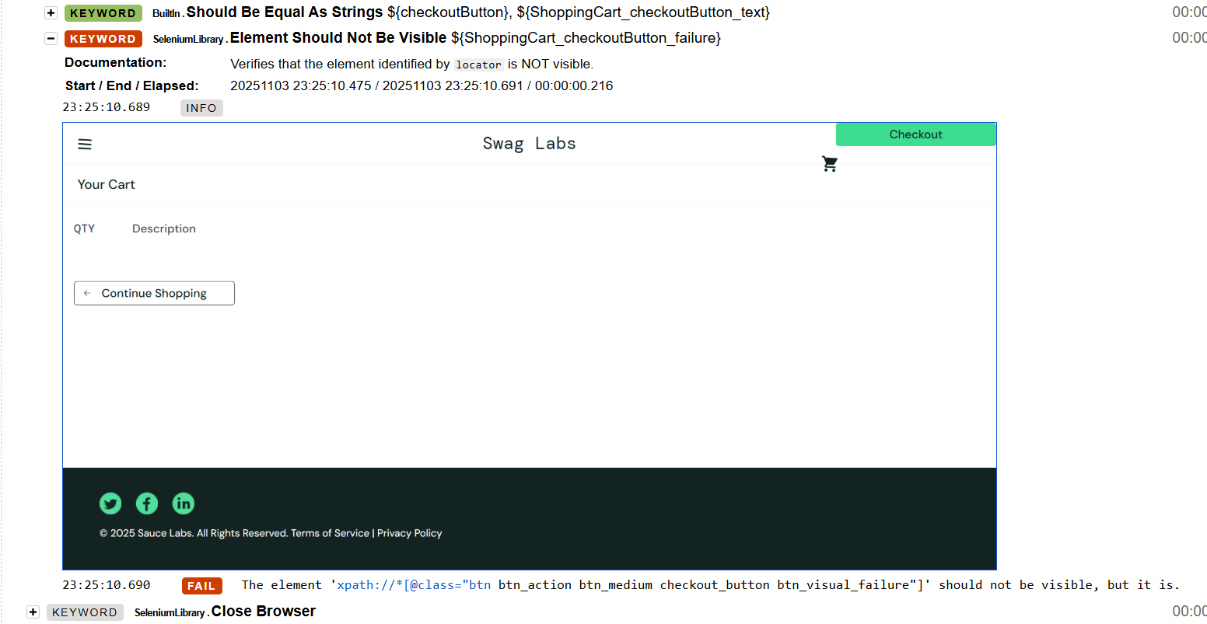

##### All users: Checkout should not be possible for empty cart

Steps to reproduce:

1. Log in using Username: visual_user and Password: secret_sauce > user is redirected to Products page Shopping Cart page
2. Add products to cart (optional step)
3. Click on Shopping cart button > user is redirected to Your cart page
4. Click on Checkout button

Expected results: Checkout option should be disabled for empty cart.

Actual results: Checkout button redirects to Checkout: Your Information page and order can be completed

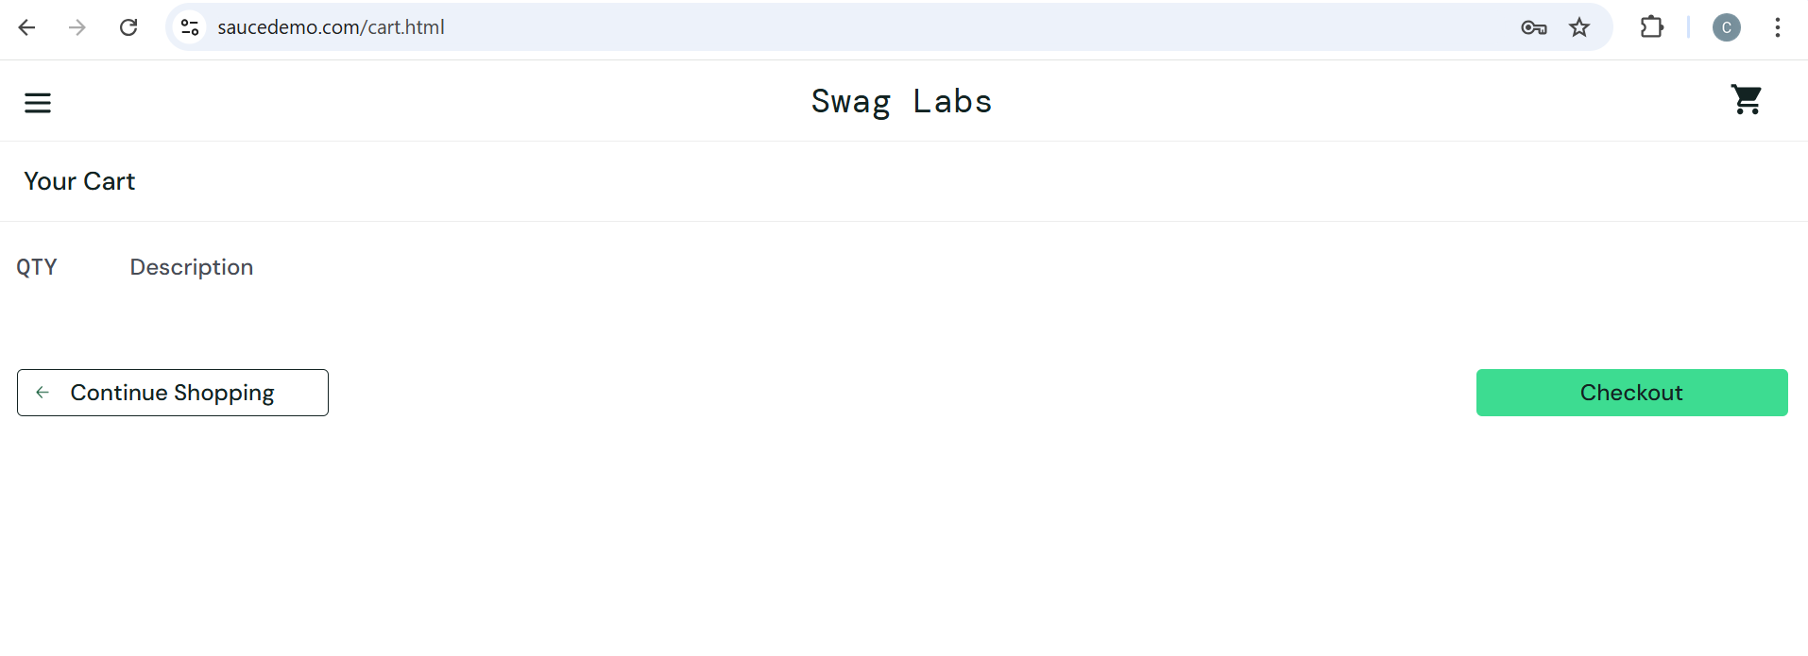

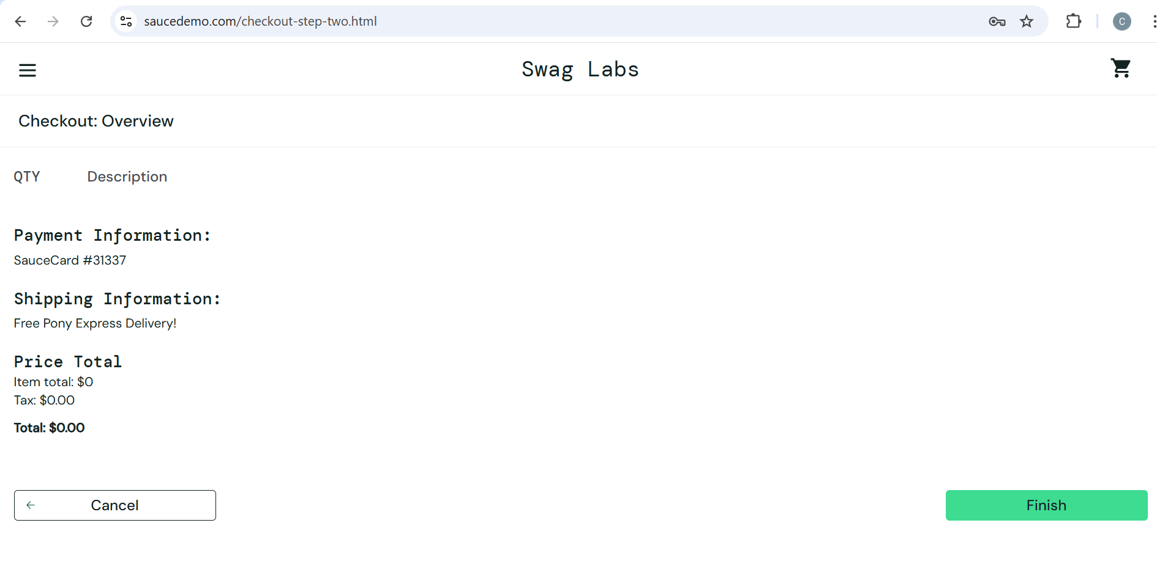

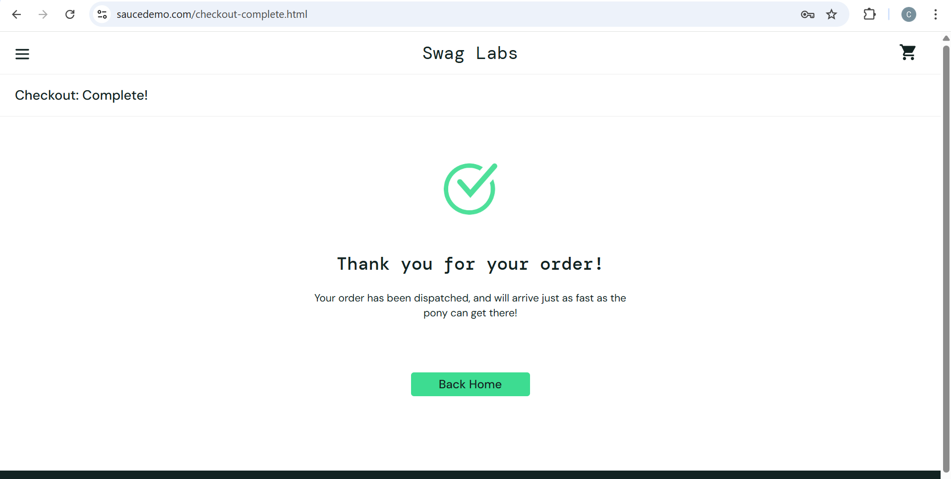

### Checkout: Your Information page

**Page Name**: Checkout – Your Information Page

**URL:** https://www.saucedemo.com/checkout-step-one.html

**File Path:** Resources/CheckoutYourInformation_page.robot, Tests/CheckoutYourInformation

_tests.robot

**Purpose**: Checkout – Your Information Page collects user mandatory shipping information (First Name, Last Name and Postal Code) before proceeding to the order summary step.

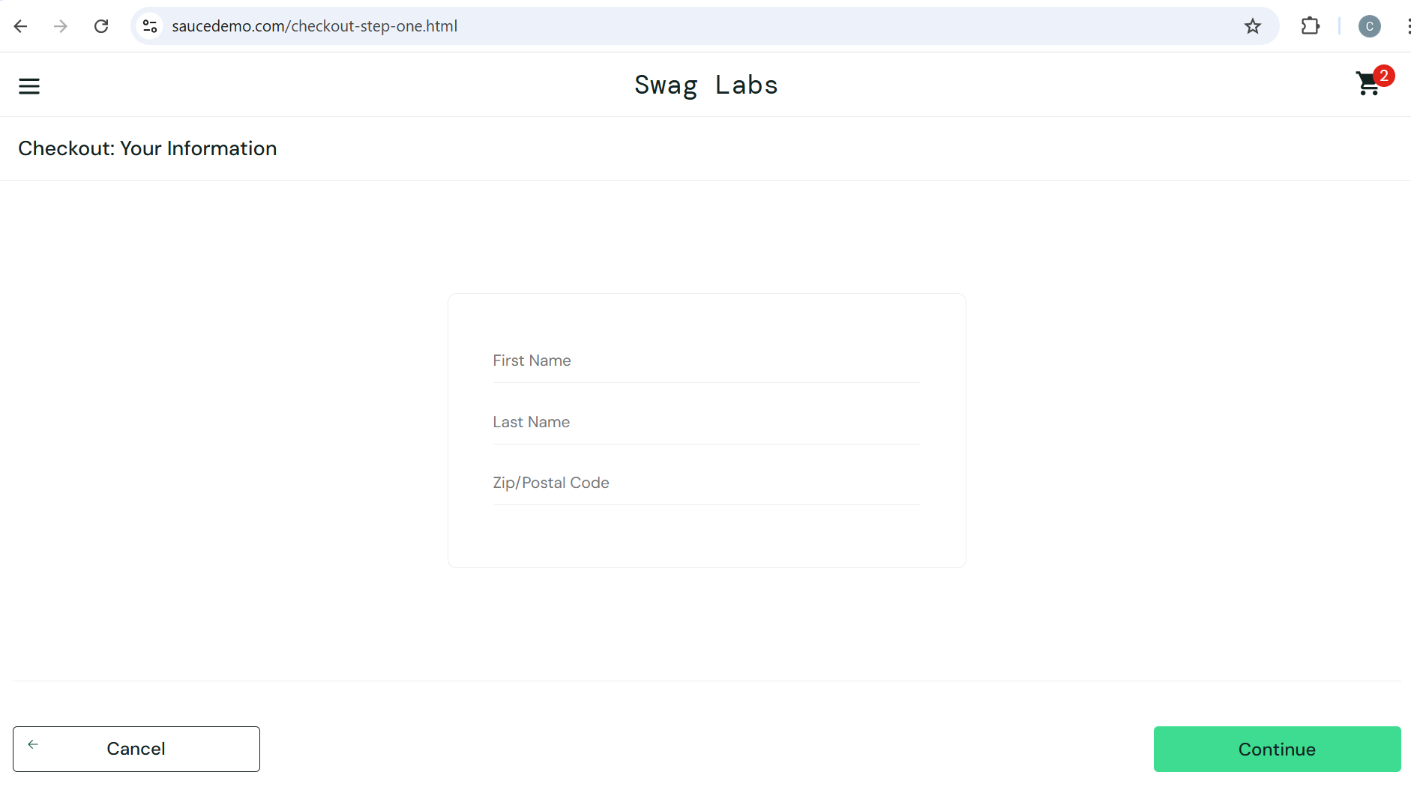

#### Defects:

##### *error_user* User can’t edit Last Name- checkout is blocked

Steps to reproduce:

1. Log in using Username: error_user and Password: secret_sauce > user is redirected to Products page
2. Products page: Add (at least) a product to cart
3. Click on Shopping Cart > user is redirected to Your Cart page, product is added in cart
4. Click on Checkout button > user is redirected to Checkout: Your Information page
5. Fill in First Name > First Name is visible
6. Fill in Last Name

Expected results: error_user can edit Last Name

standard_user example: 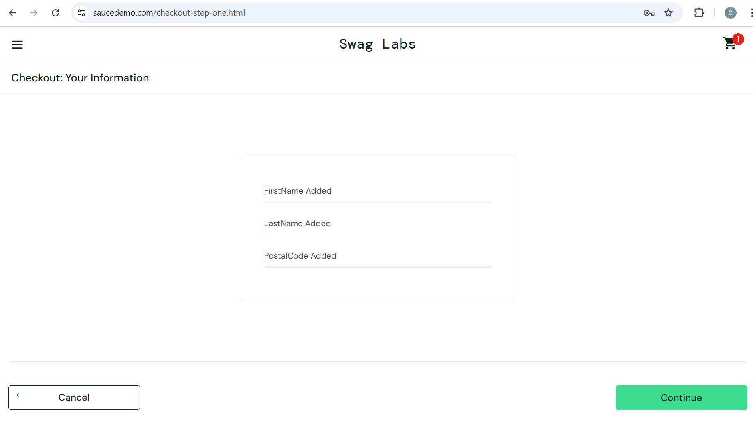

Actual results: error_user can’t edit Last Name

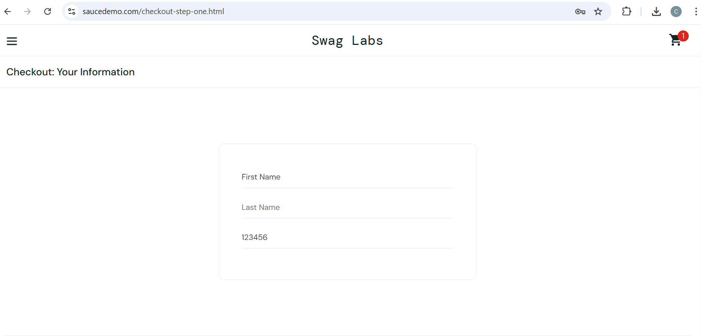

Test failed:

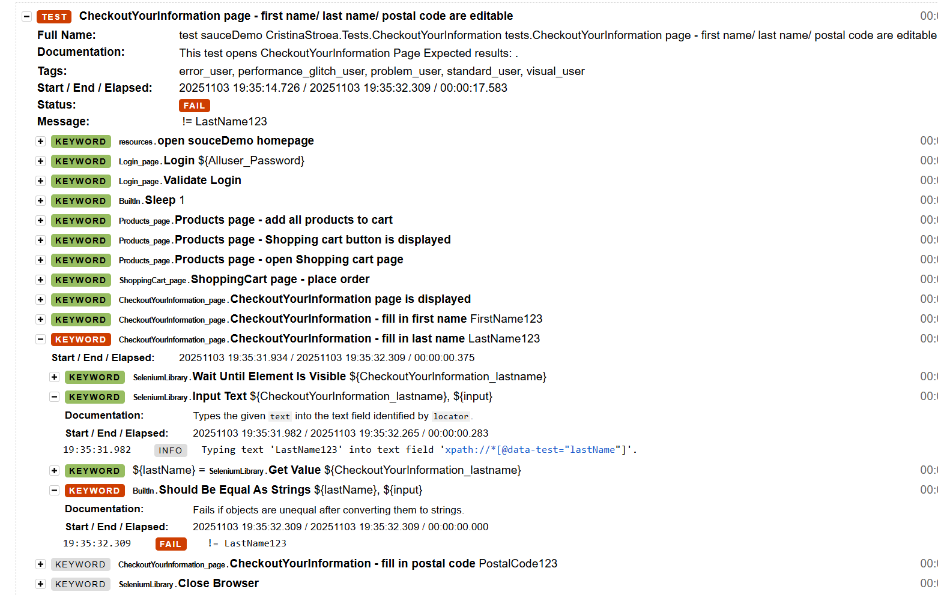

##### *error_user* Last Name is not mandatory during checkout process

Steps to reproduce:

1. Log in using Username: error_user and Password: secret_sauce > user is redirected to Products page
2. Products page: Add (at least) a product to cart
3. Click on Shopping Cart > user is redirected to Your Cart page, product is added in cart
4. Click on Checkout button > user is redirected to Checkout: Your Information page
5. Fill in First Name > First Name is visible
6. Fill in Postal Code > Postal Code is visible
7. Click on Continue button

Expected results:

Last name is mandatory. Error returned: Error: Last Name is required

Standard_user example: 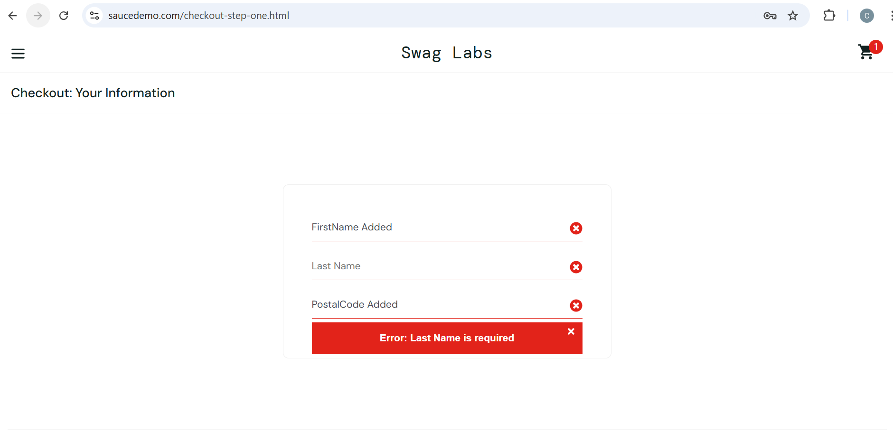

Actual results:

error_user is redirected to Checkout: Overview page.

Finish button is not working on Checkout: Overview page.

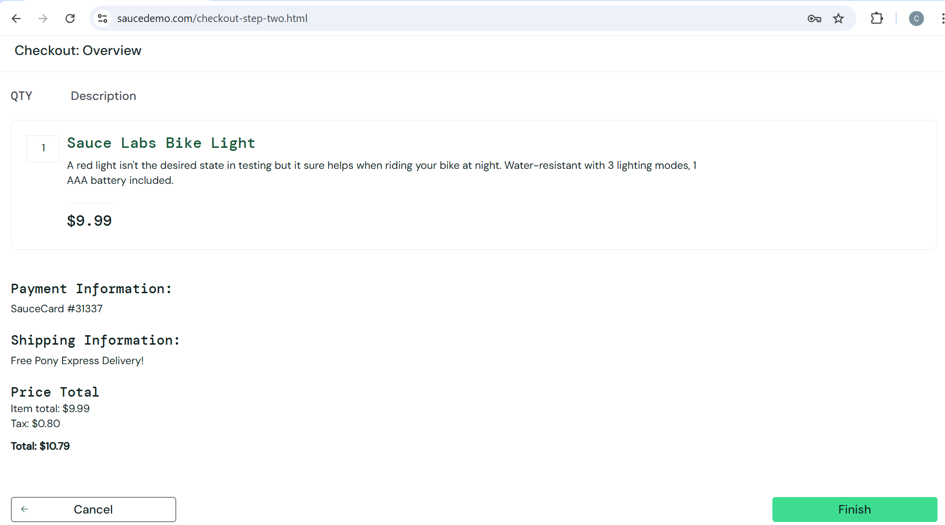

##### problem_user: first name is overwritten by last name

Steps to reproduce:

1. Log in using Username: problem_user and Password: secret_sauce > user is redirected to Products page
2. Products page: Add (at least) a product to cart
3. Click on Shopping Cart > user is redirected to Your Cart page, product is added in cart
4. Click on Checkout button > user is redirected to Checkout: Your Information page
5. Fill in First Name > First Name is visible
6. Fill in Last Name

Expected results: First Name and Last Name are filled in

Actual results: First Name is overwritten by Last Name (1 charcter)

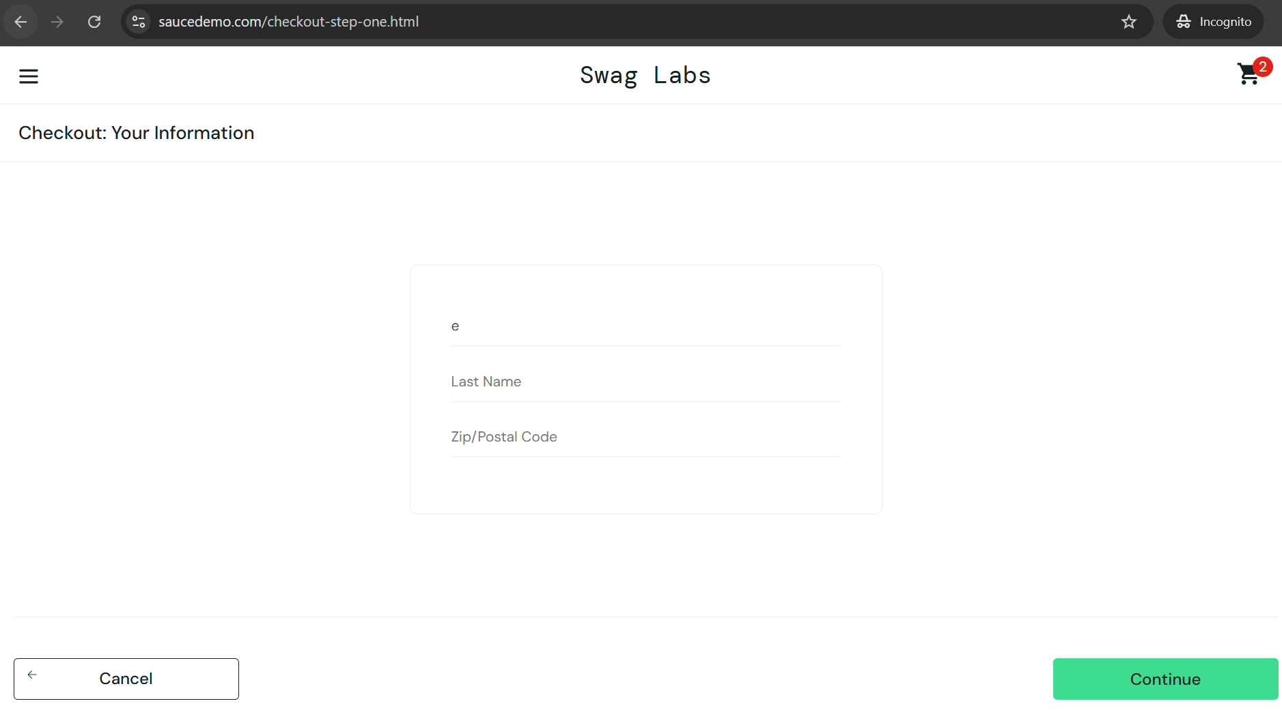

### Checkout: Overview Page

**Page Name**: Checkout – Overview Page

**URL:** https://www.saucedemo.com/checkout-step-two.html

**File Path:** Resources/CheckoutOverview_page.robot, Tests/CheckoutOverview

_tests.robot

**Purpose**: Checkout – Overview Page allows the user to complete the order or cancel/go back

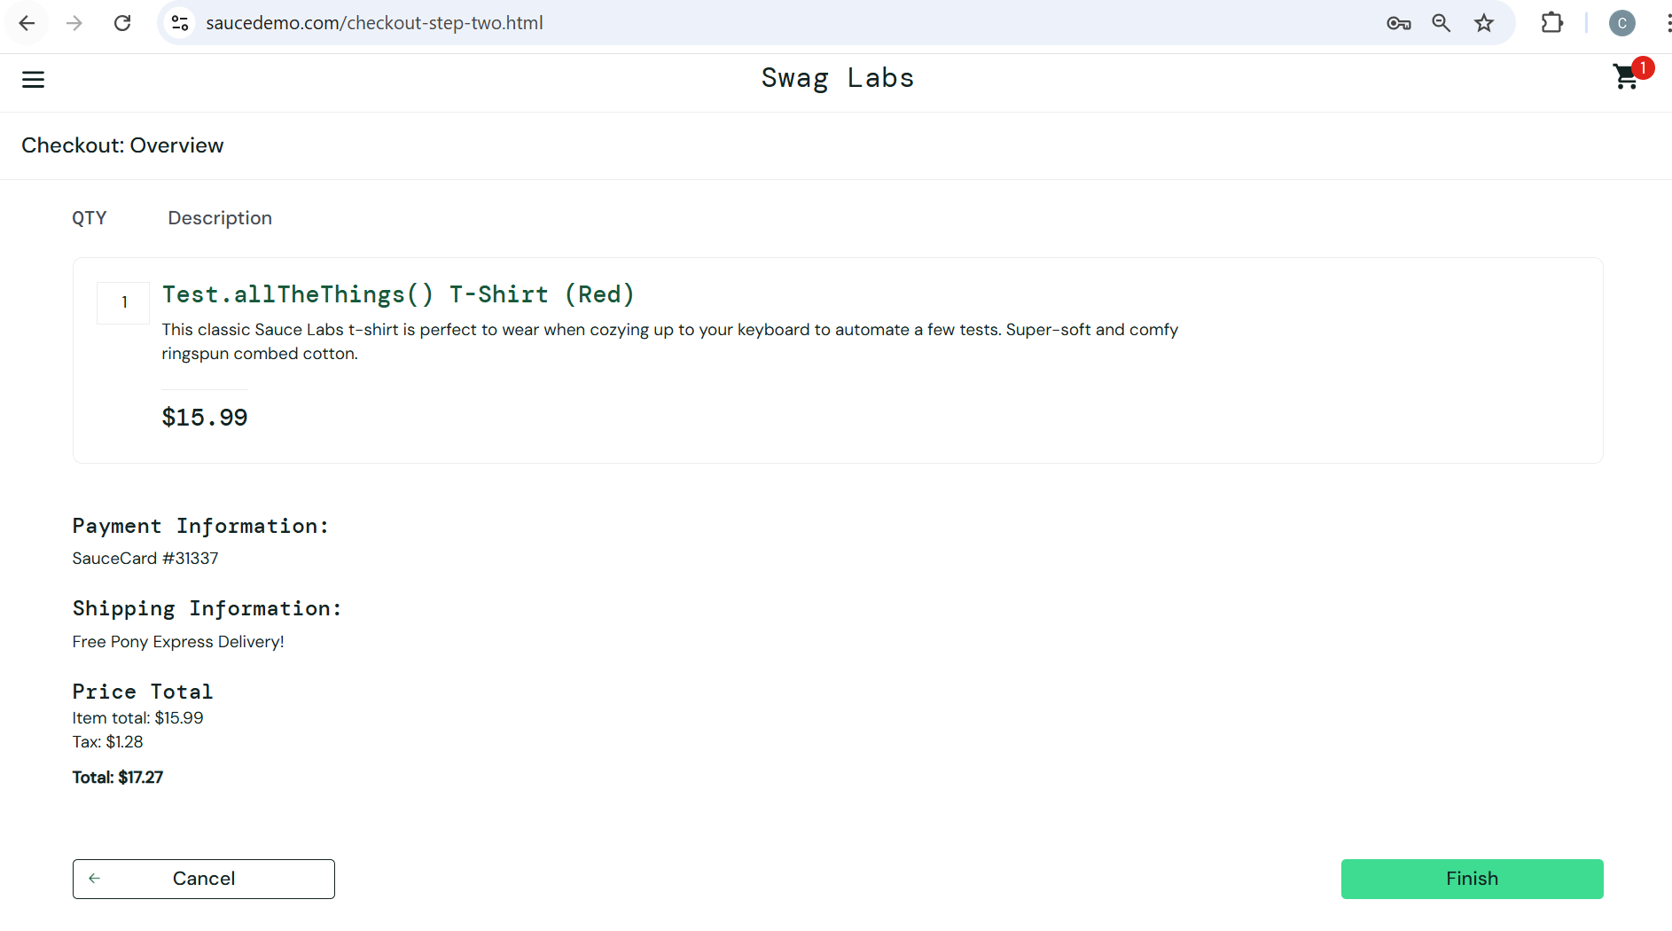

### Checkout: Complete Page

**Page Name**: Checkout – Complete Page

**URL:** https://www.saucedemo.com/checkout-complete.html

**File Path:** Resources/CheckoutComplete_page.robot, Tests/CheckoutComplete

_tests.robot

**Purpose**: Checkout – Complete Page The Checkout Complete page confirms successful order placement.

Back Home button returns the user to the Products page.

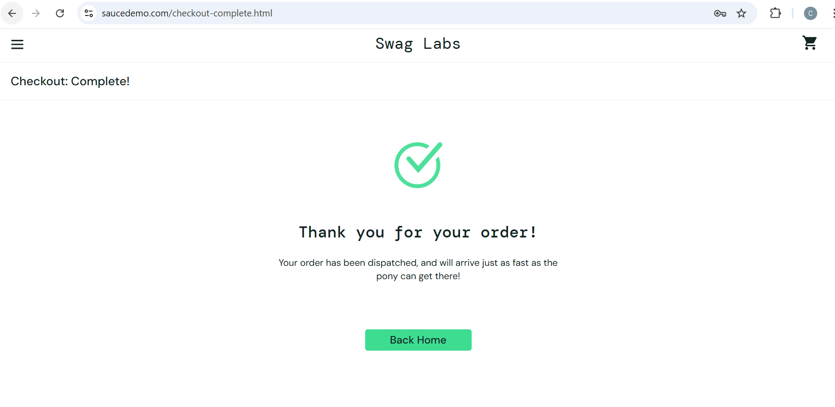

## Generated report

Example - standard_user:

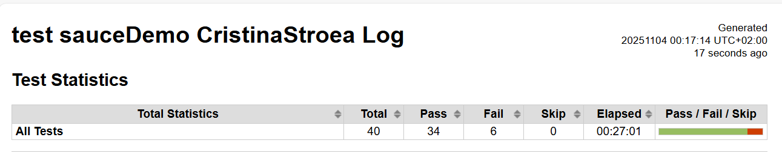

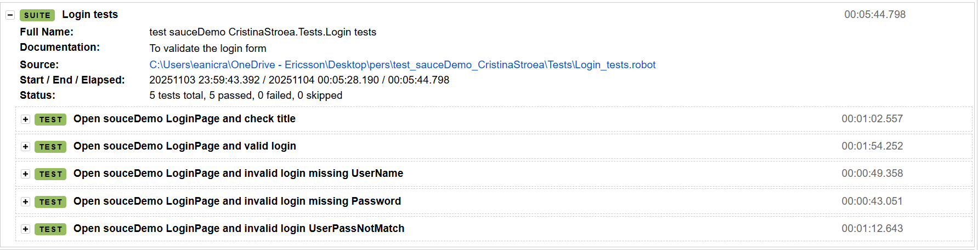

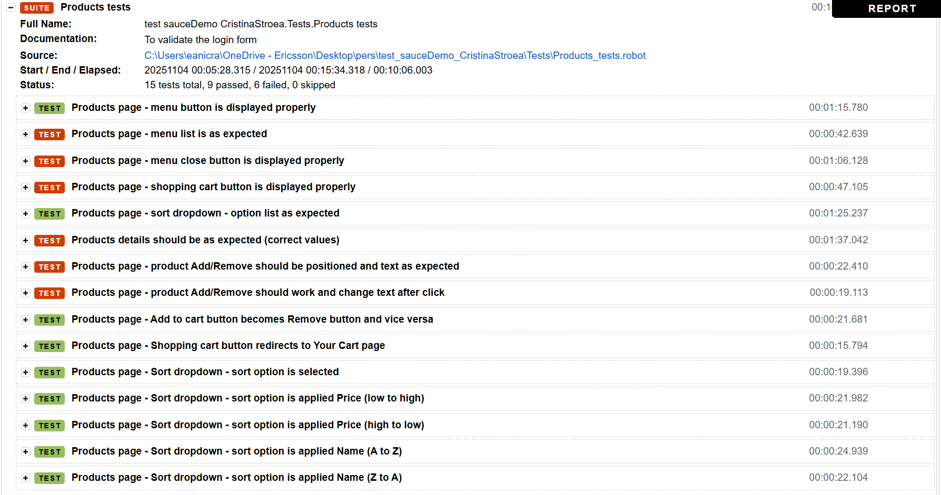

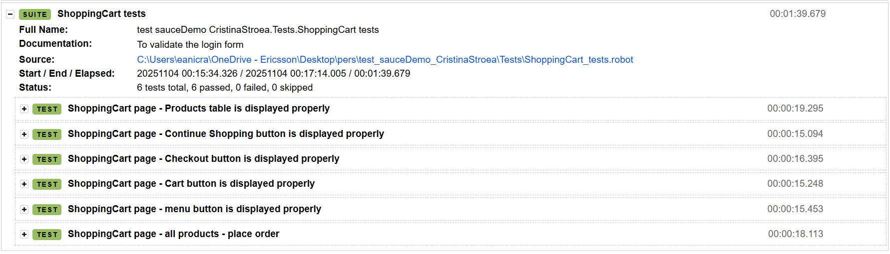

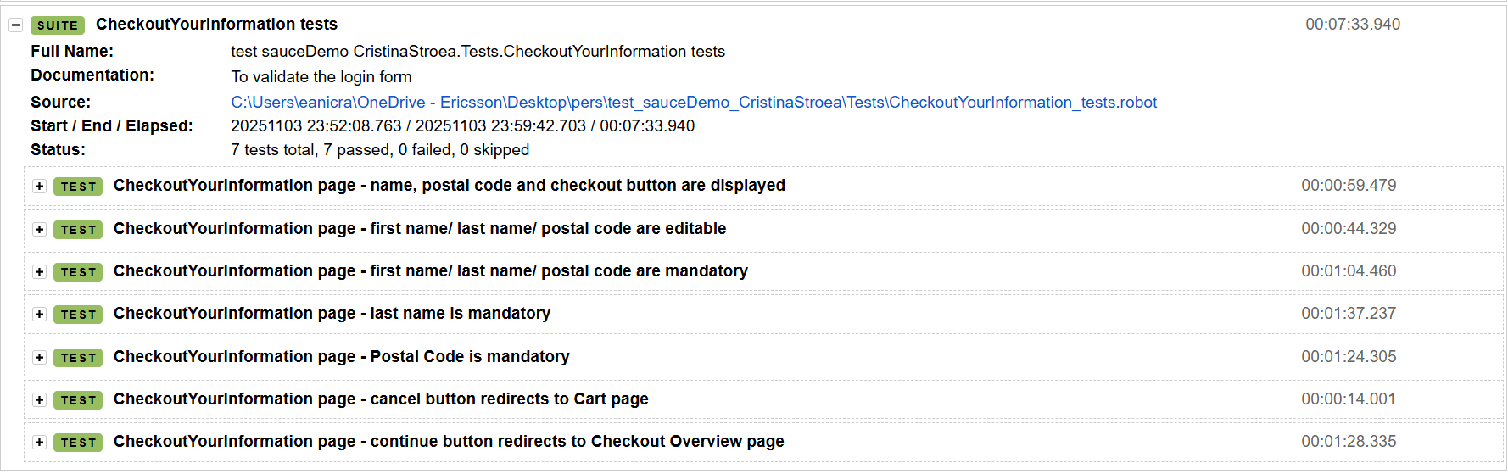

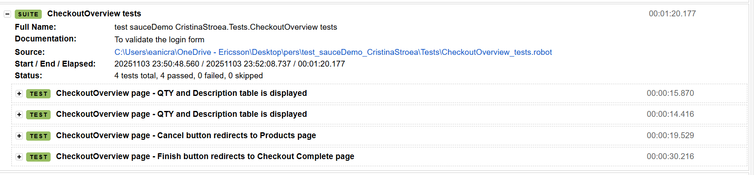

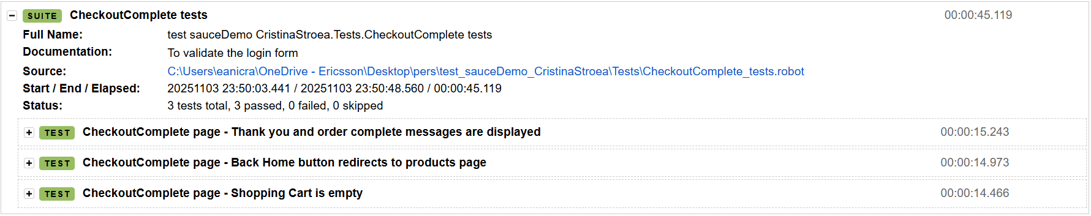

## Contacts / References

QA Engineer: Cristina Stroea / [andreicristina422a@yahoo.com](mailto:andreicristina422a@yahoo.com)

Repository: Git link